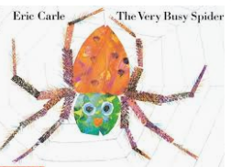

**‘The Very Busy Spider’ Writing Challenges**

In the story the animals ask the spider lots of questions.

When we write speech, we use inverted commas at the beginning of the speech and at the end to finish the speech.

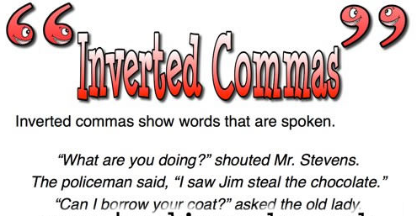

Can you put inverted commas around the spoken words of the animals?

Can you match the word to the picture?

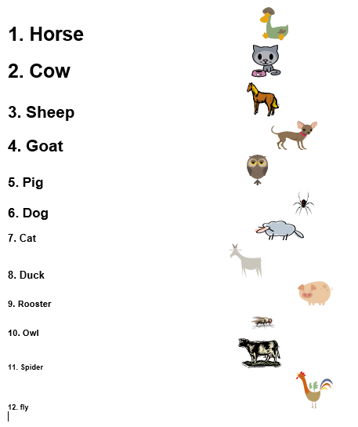

<https://www.youtube.com/watch?v=TfL0g-XRxnA>

Watch the Very Busy Spider.

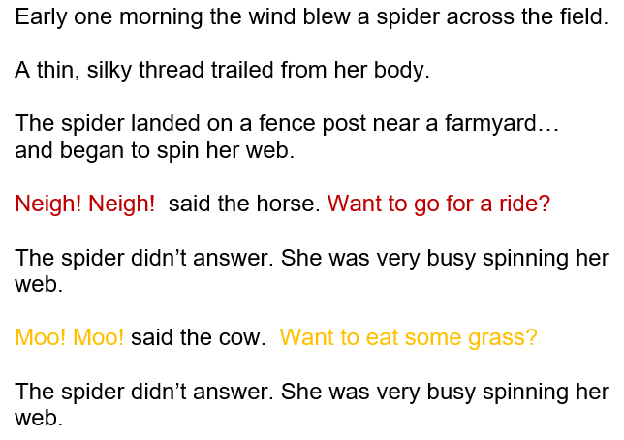

Which animal is asking the question? Can you put inverted commas around the speech?

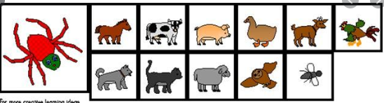

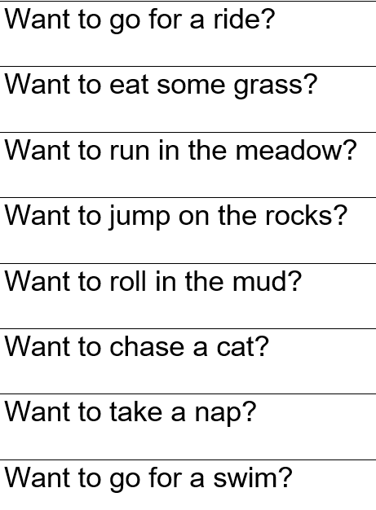

Can you write a letter to the spider and ask her to do something with you?

If your idea is fun or exciting she may stop spinning her web!

