Design a game which is based around a well known traditional tale. Remember to include your rules of how to play.  Play it with your family!  Bring it into school so we can all join in. | Design and make a new house for the 3 little pigs.  Make sure it’s wolf proof!  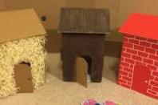 | Pretend you are Goldilocks. Write a postcard or letter to the 3 bears. Explain how you are sorry and why they should forgive you.
Plant your own bean. Look after it and measure it using a ruler. How tall does it grow?  Take a photo or keep a diary of your bean! | Make some gingerbread men and decorate them.  Follow the recipe carefully and measure the ingredients carefully. | WILD TASK!  Come up with your own ideas!  Painting, writing, making, maths investigation…..this list is endless!
Once upon a time……

