Fractions
Foundation Stage Objectives:
- Solve practical problems involving sharing and halving. See Division section of policy.
Year 1 Objectives:
- Recognise, find and name a half as one of two equal parts of an object, shape or quantity.
- Recognise, find and name a quarter as one of four equal parts of an object, shape or quantity.
Concrete | Pictorial | Abstract
Pupils will use practical objects, including within their role play and outside areas to find 1/2 and 1/4 of different amounts and shapes.
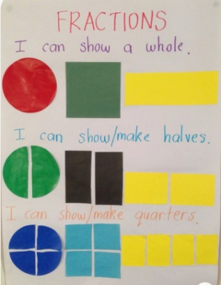  Bar Model using strips of paper, l find 1/2 and 1/4 by folding and cutting different sizes and shapes in order to support their understanding of fractions.  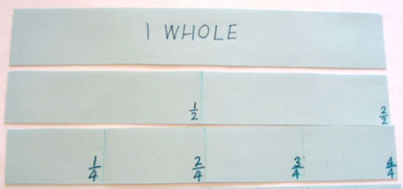 | E.g. find half ( ½) of the items on each picture or shape. Do the same for a quarter (1/4).  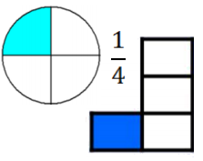  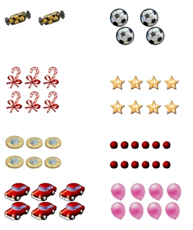  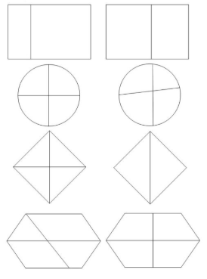  Repeat with shapes: Which have been cut exactly into quarters? | Half of 10 = 5  1/2 of 6 = 3  A quarter of 20 =  1/4 of 8 = 2
Year 2 Objectives:
- Recognise, find, name and write fractions 1/3 , 1/4 , 2/4 and 3/4 of a length, shape, set of objects or quantity
- Write simple fractions for example, 1/2 of 6 = 3 and recognise the equivalence of 2/4 and 1/2 .
Concrete | Pictorial | Abstract
Recognising 1/3. 1/4 2/4 and 3/4  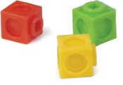  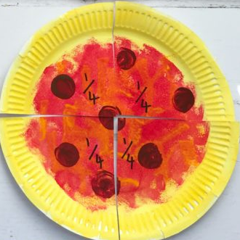 | 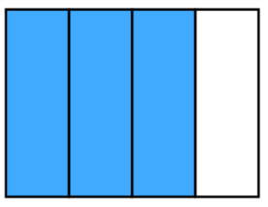  Find different ways of finding fractions of shapes  3/4 of a rectangle, for example.  2/4 of a quantity.  2/4 of 8 = 4  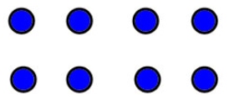 | 1/3 of 9 = 3  2/4 of 8 = 4  3/4 of 12 = 9
Recognise equivalence.  1/2 = 2/4 | 2/4 of a pie = 1/2 of a pie  1/2 of 12 = 2/4 of 12 | 1/2 of 12 = 6  2/4 of 12 = 6
Year 3 Objectives:
- Recognise and show, using diagrams, equivalent fractions with small denominators
- Recognise, find and write fractions of a discrete set of objects: unit fractions and non-unit fractions with small denominators
- Add and subtract fractions with the same denominator within one whole [for example, 5/7 + 1/7 = 6/7 ]
- Solve problems involving increasingly harder fractions to calculate quantities, and fractions to divide quantities, including non-unit fractions where the answer is a whole number
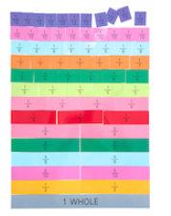  Recognise and show equivalent fractions using fraction bars/strips, for example | 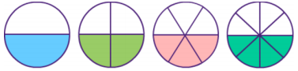  1/2 2/4 3/6 4/8 | David says two sixths is the same as one third. Is he correct? How do you know?
Fractions of a discrete set of objects.  Unit fraction 1/8  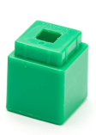  Non-unit fraction 3/7 | 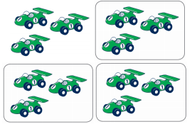  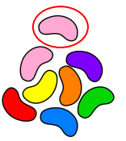  1/8 3/4 | 1/5 of 15 sweets = 3  (15 ÷ 5 = 3)  2/5 of 15 sweets = 6  (15 ÷ 5 = 3 and 3 x 2 = 6)
Add and subtract fractions with the same denominator within 1 whole.  Comparing the two fractions and finding the difference/  4/5 - 3/5 = 1/5 | +  =  _  = | 8/12 + 3/12 = 11/12  4/5 - 3/5 = 1/5
Solve problems: | David spent 1 /4 of his money on a book. The book cost £10. How much money did he start off with?  Total Money?  1/4 £10 1/4 £10 1/4 £10 1/4 £10 | 1/4 = £10  4 x £10 = £40
Concrete | Pictorial | Abstract
Year 4 Objectives:
- Add and subtract fractions with the same denominator
- Solve problems involving increasingly harder fractions to calculate quantities, and fractions to divide quantities, including non-unit fractions where the answer is a whole number
Concrete | Pictorial | Abstract
Adding and subtracting fractions as above  Solve problems including non-unit fractions  Use counters/play money to find 2/3. | 2/3 of £18 =  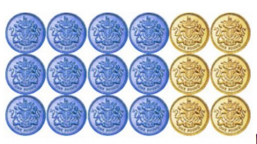 | 3/8 + 5/8 = 8/8 (same as 1 whole)  6/7 – 4/7 = 2/7  2/3 of £18 =  £18 ÷ 3 = £6  £6 x 2 = £12
Year 5 Objectives:
- Add and subtract fractions with the same denominator and denominators that are multiples of the same number
- Recognise mixed numbers and improper fractions and convert from one form to the other and write mathematical statements > 1 as a mixed number [for example, 2/5 + 4/5 = 6/5 = 1 1/5 ]
- Multiply proper fractions and mixed numbers by whole numbers, supported by materials and diagrams
Concrete | Pictorial | Abstract
Add and subtract fractions with same denominator and denominators that are multiples of the same number, and recognise mixed numbers and improper fractions.  2/3 + 2/3 = 4/3 = 1 1/3 | + = +  4/6 + 3/6 = 1 whole + 1/6  (7/6)  2/5 - 1/4 =  8/20 - 5/20 = 3/20 | 4/6 + 3/6 = 7/6 = 1 1/6  1 1/6 = 7/6 (because 1 = 6/6)  2/5 - 1/4 =  2/5 - 1/4  X4 x5  8/20 - 5/20 = 3/20
Multiply proper fractions and mixed numbers by a whole number  6 x 3/4  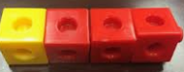 | 6 x 3/4 = 4 2/4  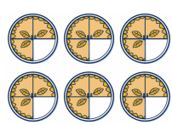 | 6 x 3/4 = 18/4 = 4 2/4 or 4 1/2
Year 6 Objectives:
- Add and subtract fractions with different denominators and mixed numbers, using the concept of equivalent fractions
- Multiply simple pairs of proper fractions, writing the answer in its simplest form [for example, 1/4 × 1/2 = 1/8 ]
- Divide proper fractions by whole numbers [for example, 1/3 ÷ 2 = 1/6 ]
Concrete | Pictorial | Abstract
Add and Subtract fractions – as year 5  With mixed numbers | 2 1/6 - 1/3  - =  2 1/6 - 1/3 = 1 5/6 | 2 1/6 - 1/3 (find the same denominator)  2 1/6 - 2/6 ( change 1 whole into a fraction  and add to the existnig fraction)  1 7/6 - 2/6 = 1 5/6
Multiply simple pairs of proper fractions.  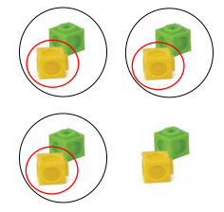  1/2 x 3/4 = 3/8 | 1/2 x 3/4  3/4 of which half is shaded | 1/2 x 3/4 = 3/8  1. Multiply the numerator.  2. Multiply the denominator.  3. Simplify where possible.  x  2 x 5 = 10 = 1  5 6 30 3  x
Divide proper fractions by whole numbers | 1/2 ÷ 3 = | 1/2 ÷ 3 = 1/6

