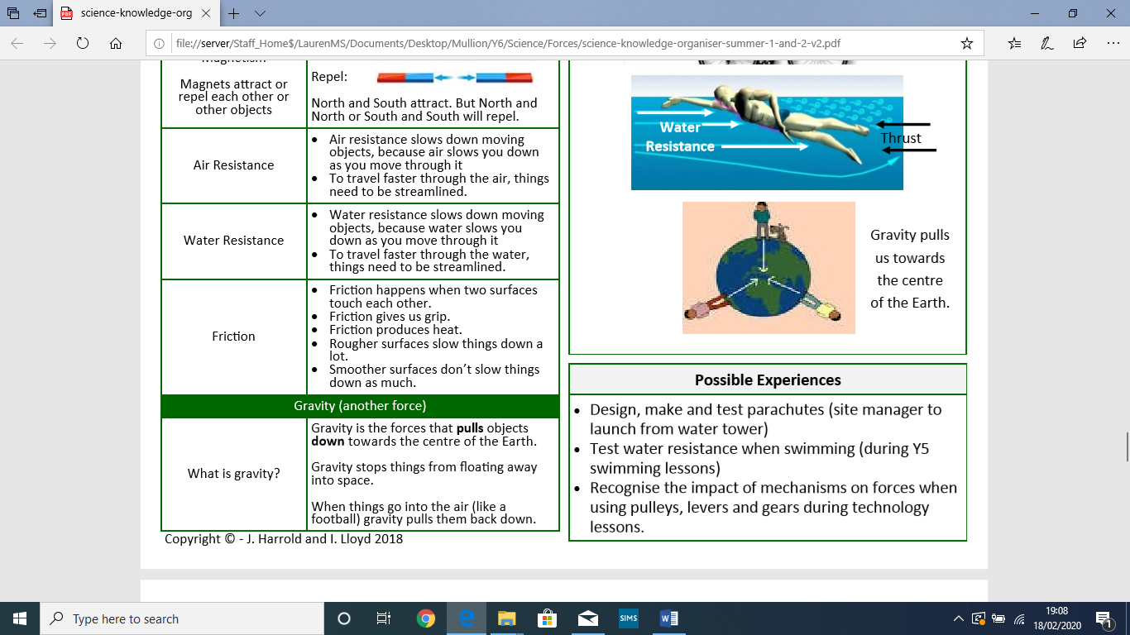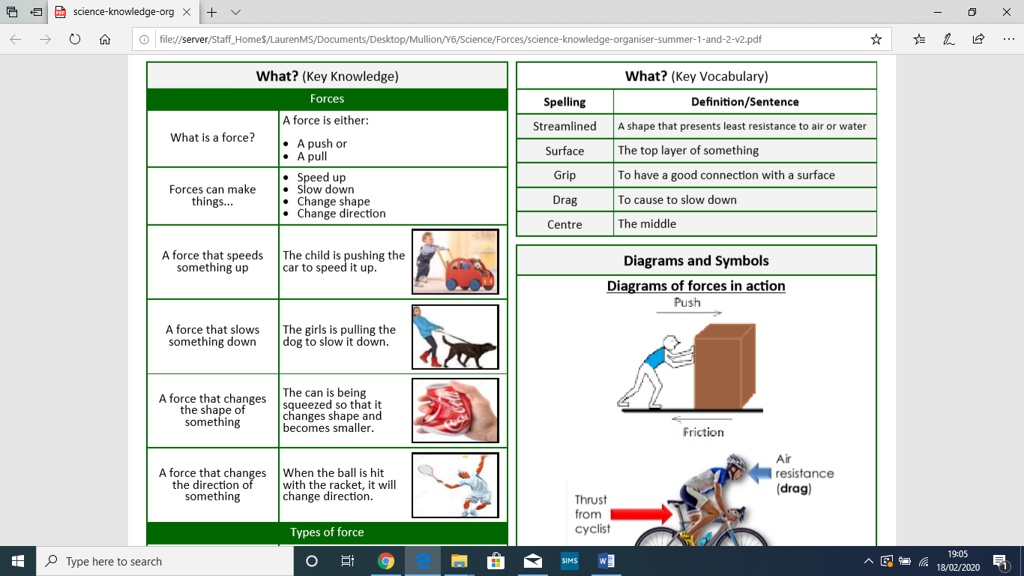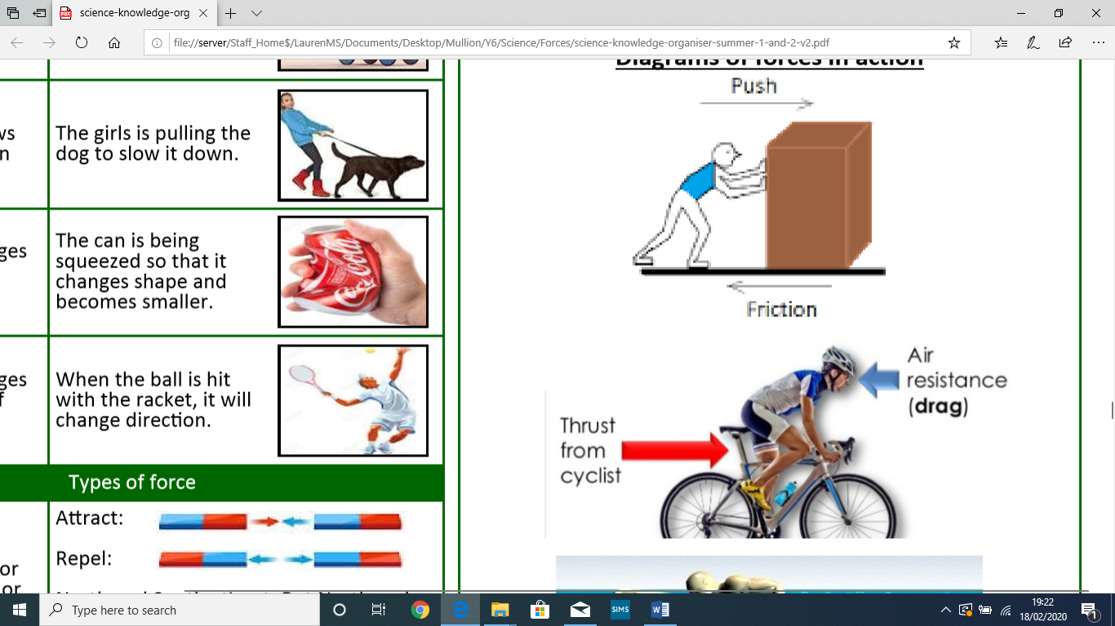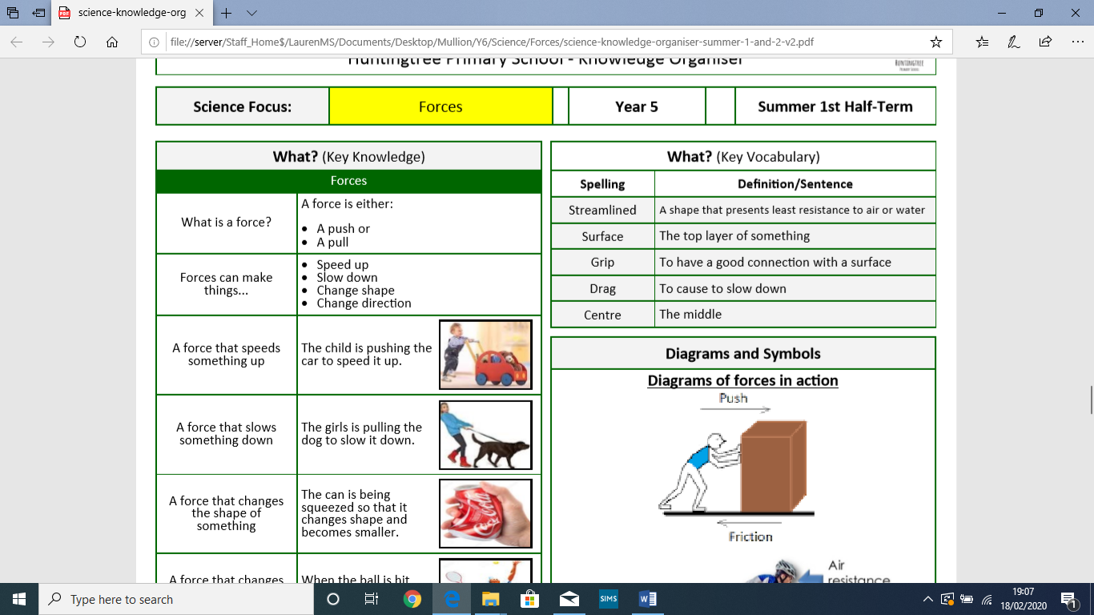

Key diagrams

Key vocabulary

Key knowledge

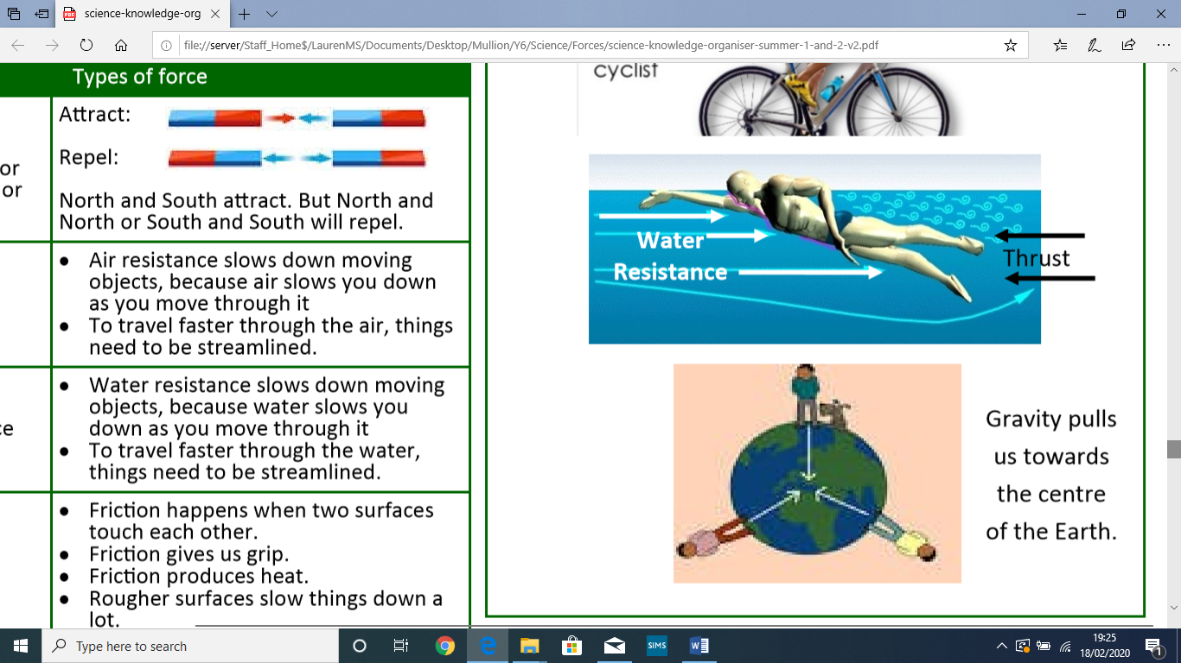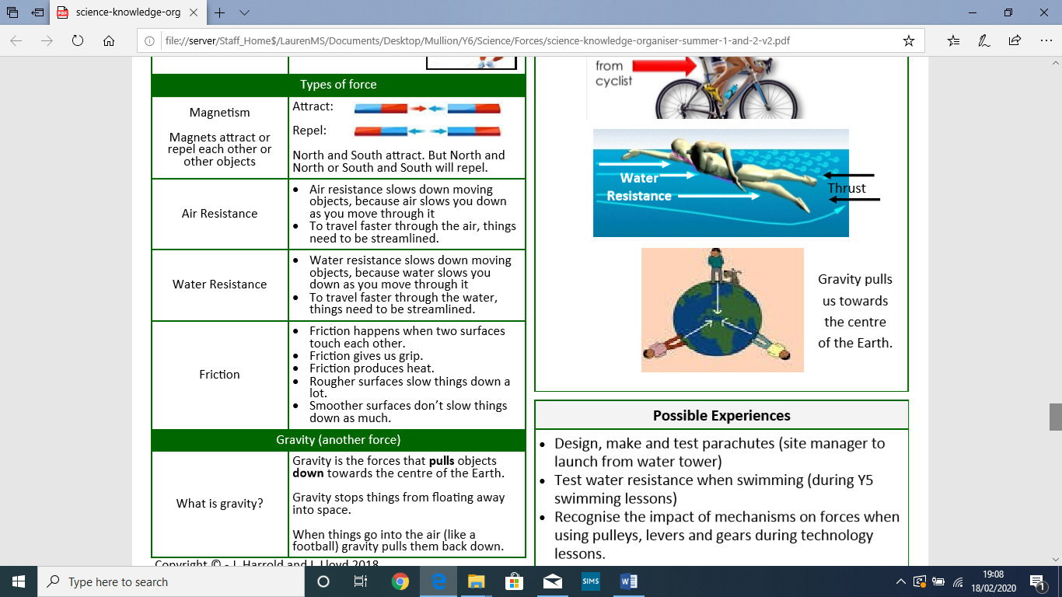

-I should be able to compare how things move on different surfaces.

-I should be able to notice that some forces need contact between two objects, but magnetic forces can act at a distance.

I should know how magnets attract or repel each other and attract some materials and not others; I should also be able to identify magnetic materials.

-I should be able to describe magnets as having two poles and be able to predict if two magnets will attract or repel each other based on which way the poles are facing.

What should I already know?

-I should be able to explain that unsupported objects fall towards the Earth because of the force of gravity acting between the Earth and the falling object.

-I should be able to identify the effects of air resistance, water resistance and friction, that act between moving surfaces

-I should be able to recognise that some mechanisms including levers, pulleys and gears allow a smaller force to have a greater effect.

What will I know at the end of the unit?