Subtraction
Foundation Stage 1 Objectives:
- Birth –to 11 months – notice changes in number of objects / images , sounds in groups of and up to 3
- 8 – 20 months - has some understanding that things exist even when out of sight
- 16-26 months – Begins to organise and categorise objects -sorting
- 22 – 36 months – knows that a group of things changes in quantity when something is added or taken away
- 30 – 50 months – separates a group of 3 or 4 objects in different ways beginning to recognise that the total is still the same

Concrete |  | Pictorial | Abstract
Use a variety of contexts, such as nursery rhymes to give purpose to the resources you use.  Use of objects in the environment – remove one to show how to ‘take away’. |  | I can count… | The use of nursery rhymes to count backwards in steps of one.  Counting back verbally – 5, 4, 3, 2, 1… in the context of stories.
Being able to separate objects and know the total is still the same.  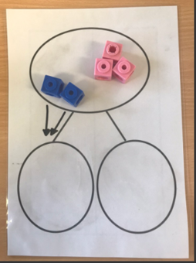 |  |  | 5 apples take away two apples leaves 3 apples.  Starting to look at the abstract.  5 – 2 = 3
Foundation Stage 2 Objectives:
- 40-60 months – Understands subtraction as taking away objects from a group and counting on how many are left.

- In practical activities and discussions begin to use the vocabulary involved in addition and subtraction.
- Early Learning Goal Children count reliably with numbers from one to 20, place them in order and say which number is one more or one less than a given number.
- Using quantities and objects, they add and subtract two single-digit numbers and count on or back to find the answer

Concrete | Pictorial |  |  | Abstract
Subtraction using concrete objects.  Hide or take away with the focus being 1 less before counting back.  Count back using out hands  (6 - 2 = 4) | Number line, with steps recorded below  Pictorial representation with crossing out to show 1 less.  E.g. 1 car left the car park…  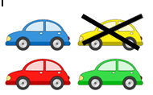 |  |  | Recording number sentences after practical activities and discussions  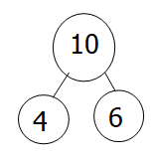  10 - 4 =6
Year 1 Objectives:
- read, write and interpret mathematical statements involving subtraction (–) and equals (=) signs
- represent and use number bonds and related subtraction facts within 20
- subtract one-digit and two-digit numbers to 20, including zero
- solve one-step problems that involve subtraction, using concrete objects and pictorial representations, and missing number problems such as
7 = – 9

Concrete | Pictorial |  |  | Abstract
Early in Year 1, use resources such as numicon to show the whole and part.  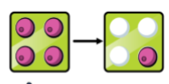 | Include place value headings in line with your school.  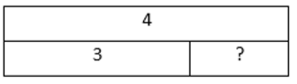 |  |  | 4  3  ?  4 – 3 = 1
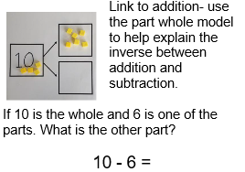 | 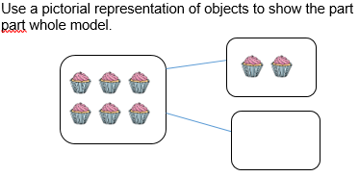 |  |  | 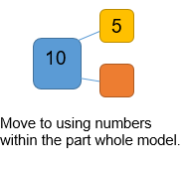
Begin with subtraction of numbers, initially with no exchange.  Make the larger number with beads, then move beads along your string as you count back.  13 – 4 =  Use resources such as tens frame and number beads to model elements of subtraction e.g. ‘crossing the tens’ boundary, counting back in ones.  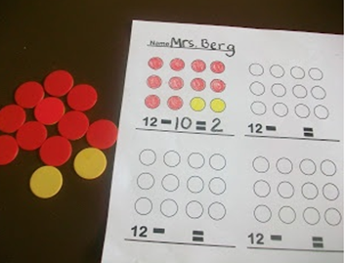  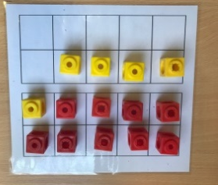 | Cross out drawn objects to show what has been taken away.  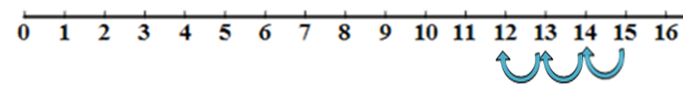  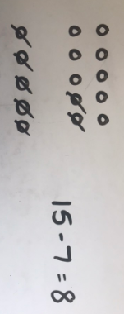 |  |  | Introduce children to problem solving using missing number problems:  15 - 3 =  15 - = 12  - 12 = 3  - = 12  Put 15 in your head, count back 3. What number are you at? Use your fingers to help.  15-7 = 8
Children practise partitioning the number they are subtracting into parts which help bridge the 10.  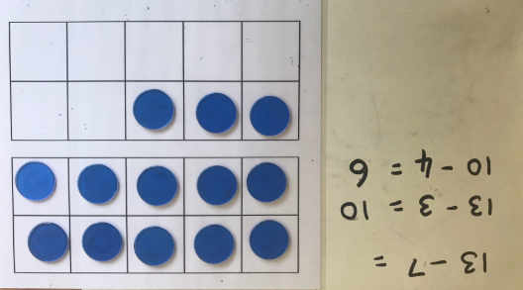 | 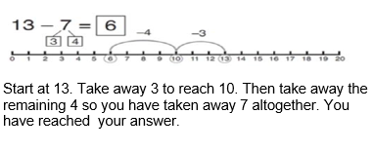 |  |  | 13 – 7 =  How many do we take off to reach 10?  13 – 3 = 10  How many do we have left to take off?  10 – 4 = 6
Use numicon to find the difference between numbers.  e.g.  The difference between 10 and 6.  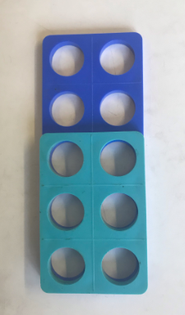  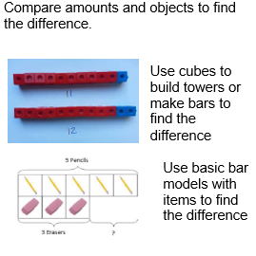 | 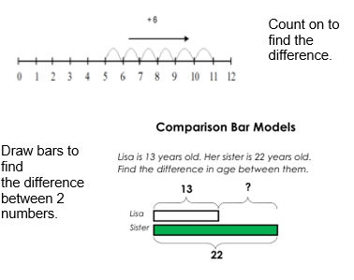 |  |  | Hannah has 22 shells; Helen has 13 shells. Find the difference between the numbers of shells.  22 – 13 = 9
Year 2 Objectives:
- solve problems with subtraction:
- using concrete objects and pictorial representations, including those involving numbers, quantities and measures
- applying their increasing knowledge of mental and written methods
- recall and use subtraction facts to 20 fluently, and derive and use related facts up to 100
- subtract numbers using concrete objects, pictorial representations, and mentally, including:
- a two-digit number and ones
- a two-digit number and tens
- two two-digit numbers
- adding three one-digit numbers
- show that addition of two numbers can be done in any order (commutative) and subtraction of one number from another cannot
- recognise and use the inverse relationship between addition and subtraction and use this to check calculations and solve missing number problems
Concrete | Pictorial |  |  | Abstract
Subtract a single digit from a two digit, initially without an exchange.  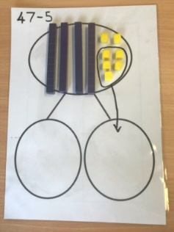  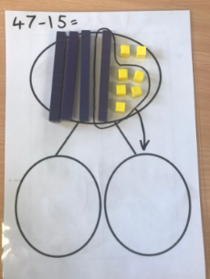 | Include place value headings in line with your school.  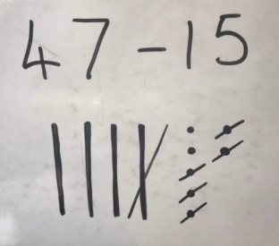  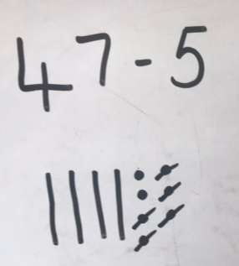  Progress to subtraction of two digits, without exchange.  Progress on to counting back/subtraction using an unmarked number line, when place value is secure :  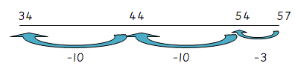  E.g. 57 – 23 = 34 |  |  | 47 – 5 = 42  47 – 15 = 32
Progressing to an exchange.  Carry out the subtraction  Create your  number  Exchange  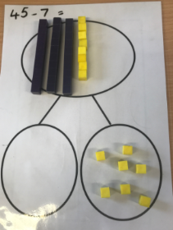  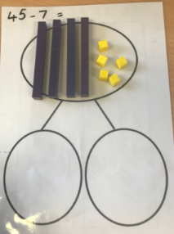  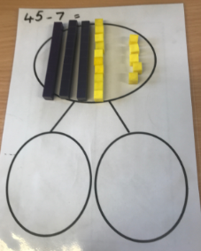 | We can either parition the number we are subtracting or the nuimber we are subtracting from.  e.g. partition the 32 into 20 and 12 or 22 and 10  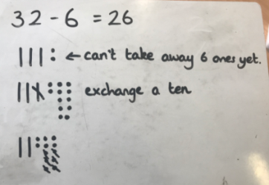  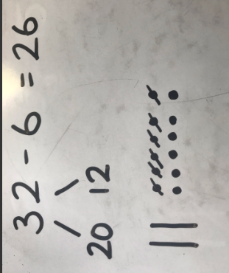  Or  Use part, part, whole to support the concept of regrouping.  Number lines can be used once the place value understanding is secure. |  |  | 45 - 7 = 38
Two digit subtract two digit, with an enxchange.  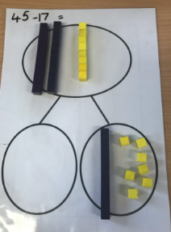  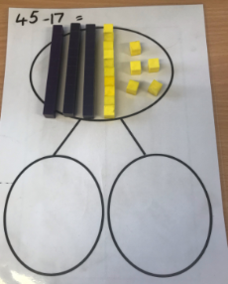  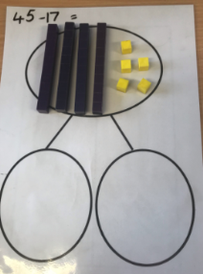  Create your  number  Carry out the subtraction  Exchange | 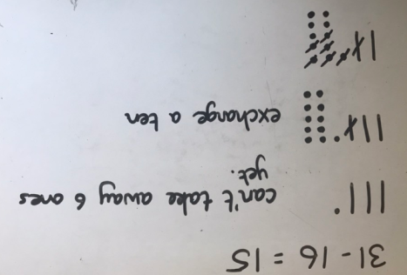  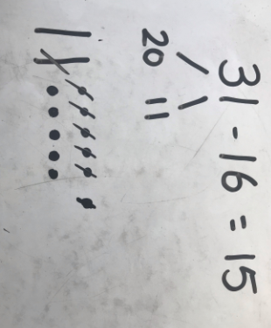  Use part, part, whole to support the concept of regrouping.  Number lines can be used once the place value understanding is secure. |  |  | 31 – 16 = 15
Use part, part, whole frames to illustrate that addition and subtraction are inverse calculations – used for missing number problems. | Use part, part, whole and bar models to illustrate and secure the structures of the mathematics.  100  40  ?  100  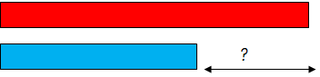  60 |  |  | 40 + 60 =  100 - = 40  60 = 100 -
Year 3 Objectives:
- subtract numbers mentally, including:
- a three-digit number and ones
- a three-digit number and tens
- a three-digit number and hundreds
- subtract numbers with up to three digits, using formal written methods of columnar subtraction
- estimate the answer to a calculation and use inverse operations to check answers
- solve problems, including missing number problems, using number facts, place value, and more complex subtraction.
Concrete | Pictorial |  |  | Abstract
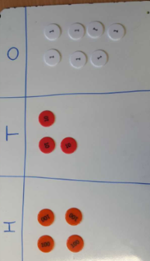  Building on Year 2, using concrete and pictorial resources before progressing to formal columnar methods, initially using the expanded form to secure place value.  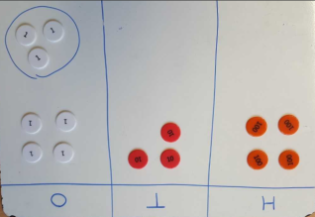 | 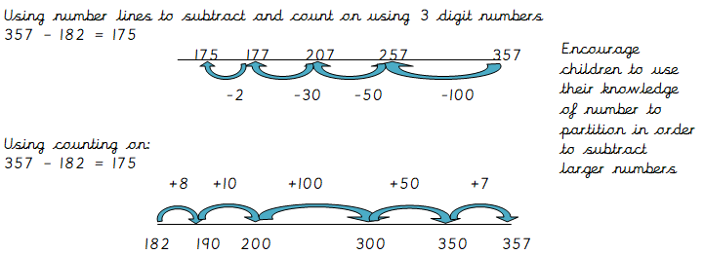  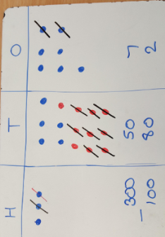  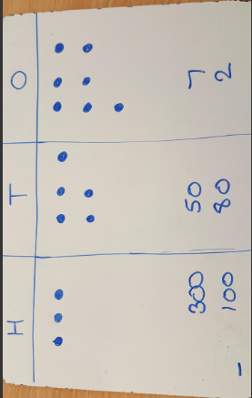 |  |  | Extended written method:  324 – 161  ₂₀₀  300 120 4  100 60 1  100 60 3 = 163  Leading to:  T O  40 7  - 20 3  20 4  Repeat for HTO – TO, leading onto compact method, ONLY if pupils are very secure  Only extending to compact if very secure.  H T O H T O  - 70 6 1 7 6  - 60 4 - 6 4  100 10 2 1 1 2
Year 4 Objectives:
- Subtract numbers with up to 4 digits using the formal written methods of columnar addition and subtraction where appropriate
- estimate and use inverse operations to check answers to a calculation
- solve addition and subtraction two-step problems in contexts, deciding which operations and methods to use and why.
Concrete | Pictorial |  |  | Abstract
Build on previous year group models and images. | Continue to explore formal columnar written method and how to exchange in order to calculate. Begin with 3 digit subtract 3 digit; moving to 4 digit subtract 3 digit and then 4 digit subtract 4 digit. At each stage, only make one exchange initially. |  |  | Continue to explore formal columnar written method and how to exchange in order to calculate. Begin with 3 digit subtract 3 digit; moving to 4 digit subtract 3 digit and then 4 digit subtract 4 digit. At each stage, only make one exchange initially. Begin to include 0 as a place holder: model how to exchange.  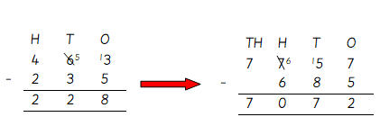  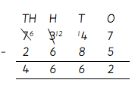  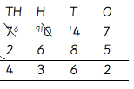
Progress to subtraction of numbers with 2 decimal places in context  £318.69 - £146.25 = £172.44  Estimate answers before calculation e.g.  318.69 – 146.25 =  320 – 150 = 170 | Use pictorial representations as shown above where appropriate. |  |  | 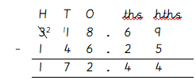
Year 5 Objectives:
- subtract whole numbers with more than 4 digits, including using formal written methods (columnar subtraction)
- subtract numbers mentally with increasingly large numbers
- use rounding to check answers to calculations and determine, in the context of a problem, levels of accuracy
- solve subtraction multi-step problems in contexts, deciding which operations and methods to use and why.

Concrete | Pictorial |  |  | Abstract
Continue to build on Year 4 before subtracting with more than 4 digits, including numbers with differing decimal places e.g 134.25 – 23.4 = |  |  |  | Subtracting 5 digit numbers, moving towards 6 digit numbers and using 0 as a place holder. Discrete teaching of the requirement to make more than one exchanges must be taught, when dealing with 0.  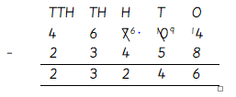  Model how to use 0 as a place holder when calculating with numbers with different decimal places.  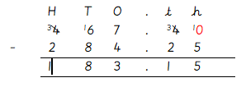
Year 6 Objectives:
- solve subtraction multi-step problems in contexts, deciding which operations and methods to use and why

Concrete | Pictorial |  |  | Abstract
Apply knowledge and understanding to the solving of different problems involving subtraction dealing with digits to 1,000,000.  Subtract numbers with up to 3 decimal places, in context such as measure. |  |  |  | 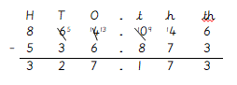
 | Use counting on to subtract smaller numbers with decimals.  2.14 – 1.3 = 0.84  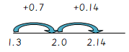  Use counting on to subtract money from multiples of 10 e.g. £50.  £50 – 32.58 = £17.42  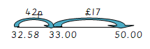 |  |  | Solve problems in real contexts e.g. A car company needed to sell 345,234 cars in 3 months. In the first month they sold 122,408 and in the second month they sold 159,386 cars. How many did they need to sell in the third month?  345,234 – (122,408 + 159,386) =63,440

