Multiplication
Foundation Stage 2 Objectives:
- 40 – 60 months - Finds the total number of items in two groups by counting all of them.
- In practical activities and discussions begins to use the vocabulary involved in multiplication
- Early Learning Goal - They solve problems, including doubling, halving and sharing.

Concrete | Pictorial | Abstract
Looking at reflections in the mirror  Make prints by folding paper in half | 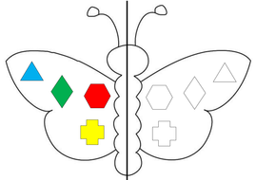
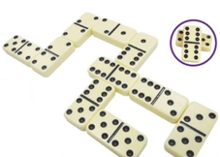  Doubling on hands and finding doubles on dominoes etc. | 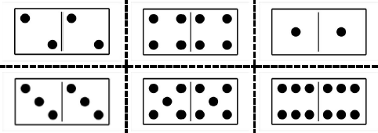 | Match the dots/colour them in…  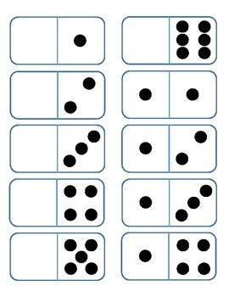
Year 1 Objectives:
- solve one-step problems involving multiplication, by calculating the answer using concrete objects, pictorial representations and arrays with the support of the teacher
- Non-statutory guidance: Through grouping small quantities, pupils begin to understand: multiplication and doubling numbers and quantities.
- They make connections between arrays, number patterns, and counting in 2s, 5s and 10s.
Concrete | Pictorial | +
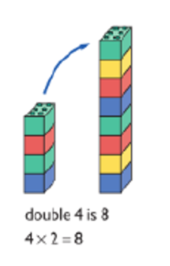  Start with doubling using concrete resources | Use diagrams to show doubling. | 2+2=4
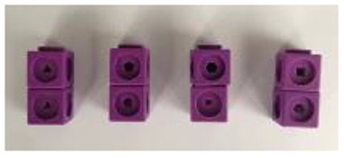  Count in 2s, 5s and 10s using resources to support | Count in 2s, 5s and 10s on your hands and recognise the patterns on number lines.  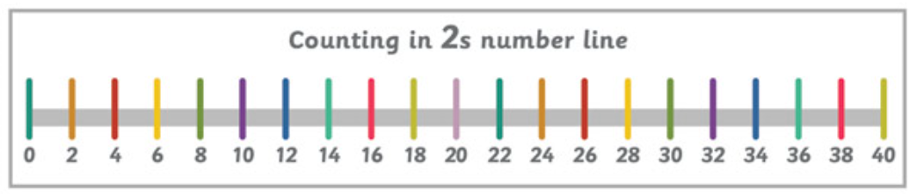 | 2,4, 6 etc.
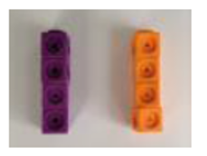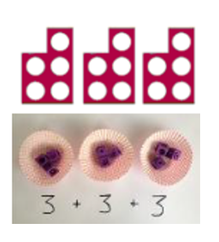  Introduce repeated addition for multiplication. Use resources to show the amount in each group. Progress on to representing this as an array. Use contextual links to problem solve.  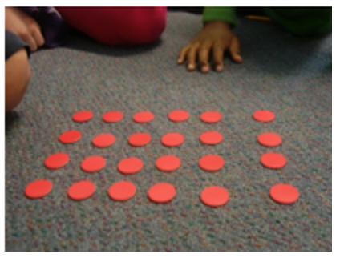  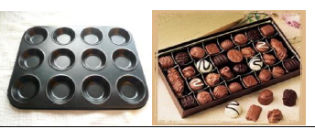 | Solve multiplication problems through repeated addition, using pictures, diagrams and own drawings to support understanding.  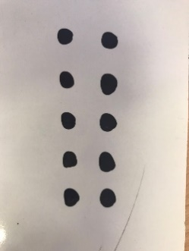  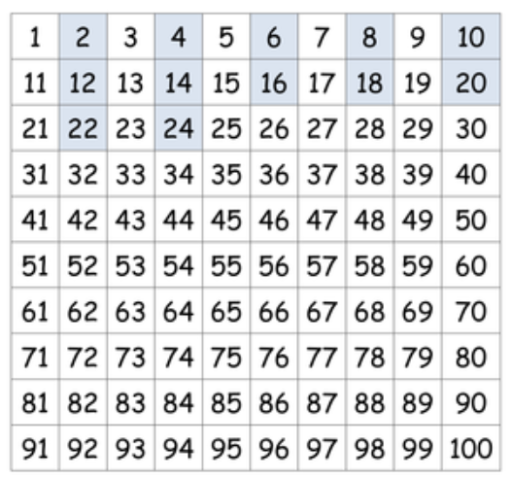  Starting to use arrays and looking for patterns when counting in multiples. | 5+5+5 = 15
Year 2 Objectives:
Pupils should be taught to:
- Count in steps of 2, 3, 5 and 10.
- recall and use multiplication facts for the 2, 5 and 10 multiplication tables, including recognising odd and even numbers
- calculate mathematical statements for multiplication within the multiplication tables and write them using the multiplication (×) and equals (=) signs
- show that multiplication of 2 numbers can be done in any order (commutative)
- solve problems involving multiplication, using materials, arrays, repeated addition, mental methods, and multiplication facts, including problems in contexts

Concrete | Pictorial | Abstract
Count in 2s, 5s and 10s using resources to support | 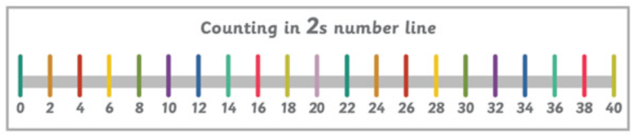  Count in 2s, 5s and 10s on your hands and recognise the patterns on number lines. | 2,4, 6 etc.
Introduce repeated addition for multiplication. Use resources to show the amount in each group. Progress on to representing this as an array. Use contextual links to problem solve. | 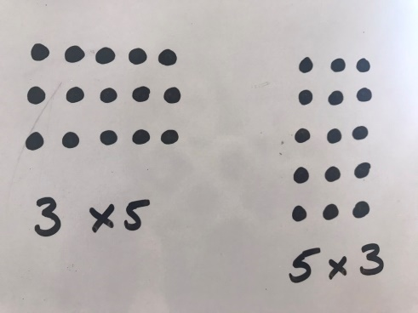  Show repeated addition as jumps on a number line.  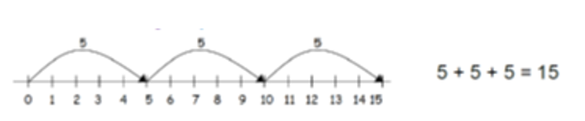  Solve multiplication problems through repeated addition, using pictures, diagrams and own drawings to support understanding when grouping.  5 5 5 | 5+5+5 = 15  3 x 5 = 15  5 x 3 = 15  (commutativity)  Relate to division facts (once division has been taught):  15÷3= 5  15÷5= 3  Variation Ideas:  2 x 3  2 x 30  2 x 300  20 x 3  200 x 3
Year 3 Objectives:
Pupils should be taught to:
- recall and use multiplication facts for the 3, 4 and 8 multiplication tables
- write and calculate mathematical statements for multiplication using the multiplication tables that they know, including for two-digit numbers times one-digit numbers, using mental and progressing to formal written methods
- solve problems, including missing number problems, involving multiplication, including positive integer scaling problems and correspondence problems in which n objects are connected to m objects

Concrete | Pictorial | Abstract
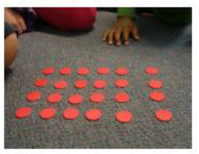  Build on use on arrays to show the commutative law. | 5 x 3 = 15  3 x 5 = 15 | 5x3=15  3x5=15  Relate to division facts:  15÷3= 5  15÷5= 3
 | 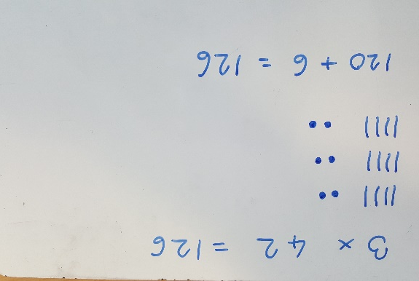 | x 40 2 =  3 120 6 126  3 x 42 = 126  3 x 40 = 120  3 x 2 = 6  120 + 6 = 126
Doubling  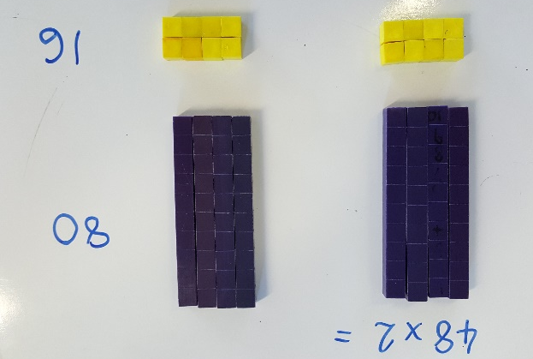 | Doubling  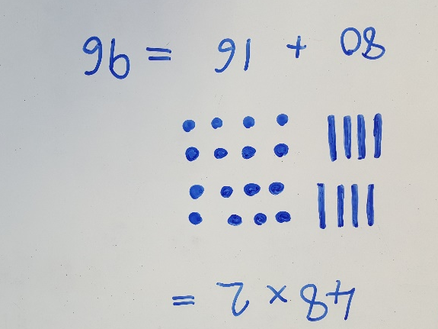 | Doubling  48 x 2 = 96  48  (40 x 2) +  80 +  (8 x 2)  16 = 96
Year 4 Objectives:
Pupils should be taught to:
- recall multiplication facts for multiplication tables up to 12 × 12
- use place value, known and derived facts to multiply mentally, including: multiplying by 0 and 1; multiplying together 3 numbers
- recognise and use factor pairs and commutativity in mental calculations
- multiply two-digit and three-digit numbers by a one-digit number using formal written layout
- solve problems involving multiplying and adding, including using the distributive law to multiply two-digit numbers by 1 digit, integer scaling problems and harder correspondence problems such as n objects are connected to m objects

Concrete | Pictorial | Abstract
See above for arrays to demonstrate commutativity.

Using partitioning of a factor to support mental approaches with multiplication  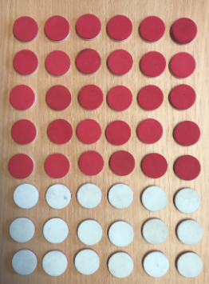 | 8 x 6  5 x 6 3 x 6  Discussion point:  Which other ways could you partition the factors?  e.g. 4 x 6 and 4 x 6 8 x 3 and 8 x 3 8 x 5 and 8 x 1  Could also been shown with a numberline | 8 x 6 =  5 x 6 = 30  3 x 6 = 18  30 + 18 = 48
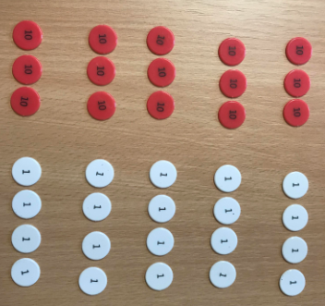  5 x 34 = | 34 34 34 34 34  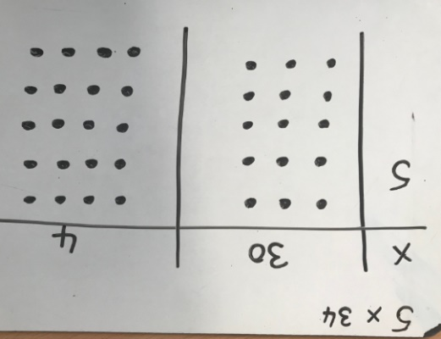  5 x 34 =  5 x 30 = 150 because 5 x 3 = 15  5 x 4 = 20  150 + 20 = 170 | x 30 4 =  5 150 20 170  150 + 20 = 170  34 x 5 =  5 x 30 = 150  5 x 4 = 20  150 + 20 = 170  3 4  x 5  2 0  1 5 0  1 7 0  This may lead to a compact method.  3 4  x ₂ 5  1 7 0
Progress onto 3 digit multiplied by a 1 digit number using the same strategies as above. |  | Demonstrate 3 x 1 digit before using compact method.  274 x 8 =  8 x 200 = 1600  8 x 70 = 560  8 x 4 = 32  1600 + 560 + 32 = 2192
Year 5 Objectives:
Pupils should be taught to:
- multiply numbers up to 4 digits by a one- or two-digit number using a formal written method, including long multiplication for two-digit numbers
- multiply numbers mentally, drawing upon known facts
- multiply whole numbers and those involving decimals by 10, 100 and 1,000

Concrete | Pictorial | Abstract
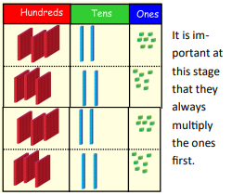  Children can continue to be supported by place value counters at this stage of multiplication. This initially done where there is no regrouping. 321 x 2 = 642 | 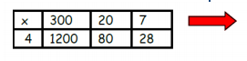 | Secure compact multiplication with 3 x 1 digit and 4 x 1 digit.  3 2 7  x 4  2 8  8 0  1 2 0 0  1 3 0 8  Leading to a compact method:  3 2 7  x 4  ₁ ₂  1 3 0 8
Multiplying 2 x 2 digit using the expanded method.  Extending onto compact multiplication before moving onto 3 and 4 digit numbers x 2 digit.  Progress onto calculations with missing numbers. | Demonstrate using the grid method 2 x 2 digit before moving to a more formal method to secure understanding.  x 30 6  20 600 120 = 720  4 120 24 = 144  720 + 144 = 864 | 3 6  x 2 4  2 4 (4 x 6)  1 2 0 (4 x 30)  1 2 0 (20 x 6)  6 0 0 (20 x30)  8 6 4  Leading to:  3 6  x 2 ₂ 4  1 ₁ 4 4  7 2 0  8 6 4
Year 6 Objectives:
Pupils should be taught to:
- multiply multi-digit numbers up to 4 digits by a two-digit whole number using the formal written method of long multiplication
- perform mental calculations, including with mixed operations and large numbers

Concrete | Pictorial | Abstract
As year 5 but progressing onto using decimals TO.t x O as an expanded calculation.  (tens, ones and tenths x ones)  If pupils are secure, they may prgress onto the compact method. |  | Expanded  T O . t  2 3 . 3  x 7  2 . 1  2 1 . 0  1 4 0 . 0  1 6 3 . 1  Compact  T O . t  2 3 . 3  x 7  ₂ ₂  1 6 3 . 1

