Minibeasts

Design and make a spider’s web

**Spiders** use their **silk** to make webs or other structures, which function as sticky nets to catch other animals, or as nests or cocoons to protect their babies.

You could use string or pipe cleaners to make you web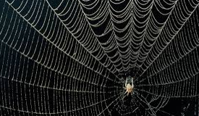

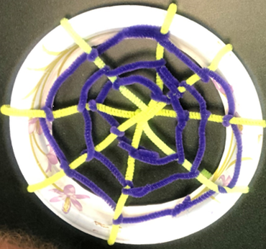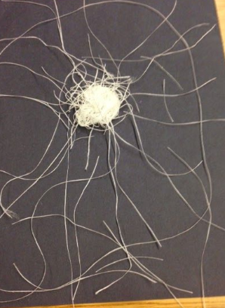 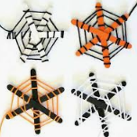

Spider Web Art

Use a wax crayon to draw the web. A white or a very light colour works best.

Used water colour paint or water down poster paints as a wash on the background. Your web should appear!

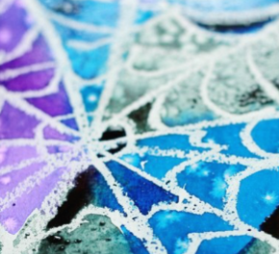

Spiders

To some of us, spiders can look a bit scary but they play a very important part

of our planet by **controlling pests**. **Spider silk** has proven to be one of the

**strongest natural materials** and is inspiring engineers all over the world.

natural material

Research, draw and Label parts of a spider

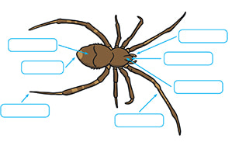

KEY WORDS

leg claw head abdomen

spinnerets palp eye

Different species of spiders can be found all over the world.

Where do the biggest spiders live?

Where might you find dangerous spiders?

Where might you find a hairy spider?

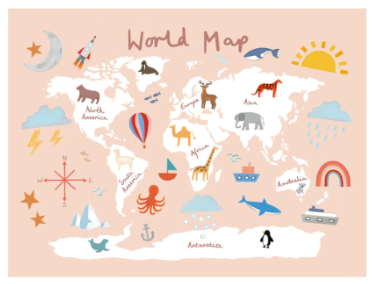

Spiders are not insects, they are **arachnids.** Can you find out what other creatures are arachnids?

How are they similar to spiders?

How are they different?

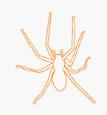

Did you know that there are over 35,000 species of spiders?

Research a species of spider and make a fact file, poster or leaflet.

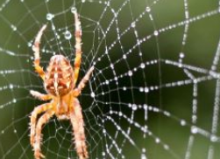

Bake creepy spider cakes!

You could make your own recipe book and write your recipe inside.

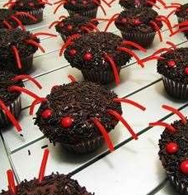

Create spider handprint art

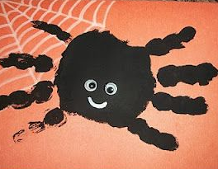

Don’t worry if you don’t have paint at home. You could draw around your hands and then decorate your spider.